

A.Y. 2026-2027

Std: XI CYCLIC TEST - 1 M. Marks: 20

Date: 27 / 04 / 2026 APPLIED MATH (241) Time: 40Mins

1 | Find the value of $x$, $2x+3=5$  A) 1 B) C) D)
2 | Find the value of $x$, $2x+3=5$  A) B)  C) D) | 3m
3 |  | 2m
10

Font : Times New Roman
Font Size 12

Line Spacing 1.15 to 1.5 depends on your subject
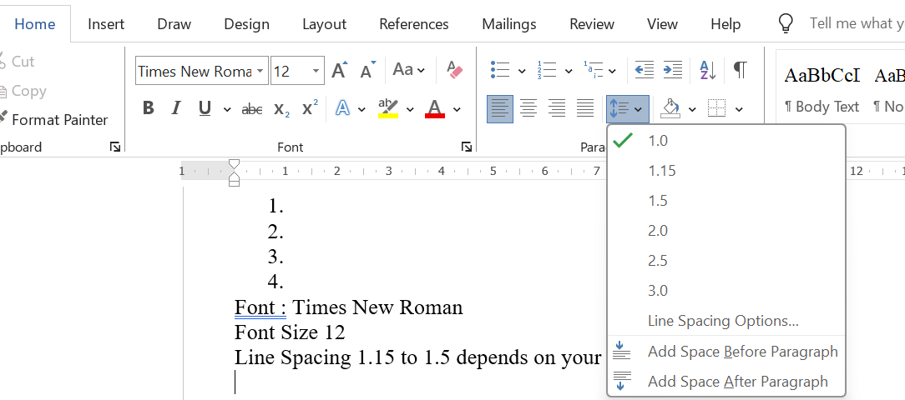

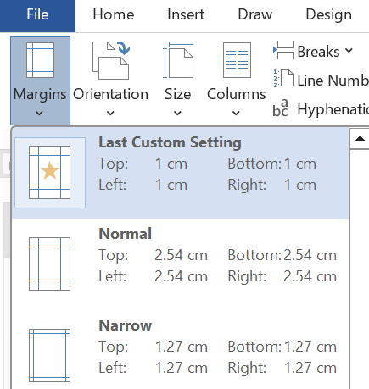
Margin 1cm each side or Narrow

